**Project Design Phase-II**

**Data Flow Diagram & User Stories**

|  |  |
| --- | --- |
| Date | 27 October 2023 |
| Team ID | 591-581 |
| Project Name | Travel Insurance Prediction |
| Maximum Marks | 4 Marks |

**Data Flow Diagrams:**

In our project the information/input will be given directly to the model through user interface (UI) of an application(mobile/web), since the model will already be trained by a dataset it will preprocess the data and gives required output by using machine learning algorithms as per the training.

**Example:** [**(Simplified)**](https://developer.ibm.com/patterns/visualize-unstructured-text/)

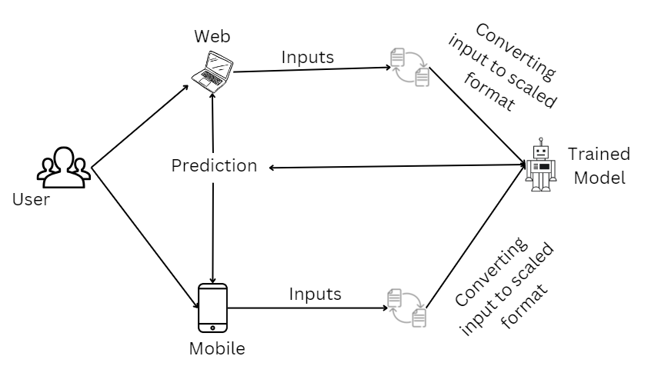

**Data Flow Diagram:**

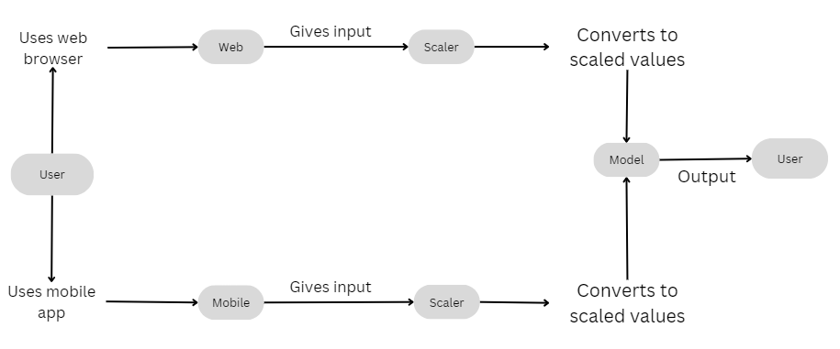

**User Stories**

Use the below template to list all the user stories for the product.

|  |  |  |  |  |  |  |
| --- | --- | --- | --- | --- | --- | --- |
| **User Type** | **Functional**  **Requirement (Epic)** | **User Story**  **Number** | **User Story / Task** | **Acceptance criteria** | **Priority** | **Release** |
| Customer  (Mobile user)/(Web User) | Age | USN-1 | As a user, I can check whether a person will take travel insurance or not based on his/her age | I can get required information | High | Sprint-1 |
|  | Employment Type | USN-2 | As a user, I can check whether a person will take travel insurance or not based on his/her Employment Type | I can get required information | High | Sprint-1 |
|  | Graduate or Not | USN-3 | As a user, I can check whether a person will take travel insurance or not by knowing if he/she is a graduate or not | I can get required information | High | Sprint-1 |
|  | Annual Income | USN-4 | As a user, I can check whether a person will take travel insurance or not based on his/her annual income | I can get required information | High | Sprint-1 |
|  | Family Members | USN-5 | As a user, I can check whether a person will take travel insurance or not based on his/her Family members | I can get required information | High | Sprint-1 |
|  | Chronic Diseases | USN-6 | As a user, I can check whether a person will take travel insurance or not based on his/her Chronic Diseases. | I can get required information | Low | Sprint-2 |
|  | Frequent Flyer | USN-7 | As a user, I can check whether a person will take travel insurance or not by seeing his/her travel enthusiasm. | I can get required information | Low | Sprint-2 |
|  | Ever travelled Abroad | USN-8 | As a user, I can check whether a person will take travel insurance or not by knowing whether he/she ever travelled abroad or not. | I can get required information | High | Sprint-1 |
|  |  |  |  |  |  |  |